**Best Local SEO Company in Noida**

When it comes to dominating the local search results, **RS Organisation** stands out as the **best Local SEO company in Noida**. We help businesses enhance their local presence, drive foot traffic, and boost visibility through data-driven strategies. Whether you’re a local shop, service provider, or franchise, our SEO experts are committed to getting your business in front of customers searching nearby. With our proven results and **affordable local SEO packages**, we are your trusted **Noida-based digital marketing agency**.

Ye images ROI, Qualified Lead and Higher sales wala h wo hum use karenge banner pe jaise wordpress k website pe image use kia h ok

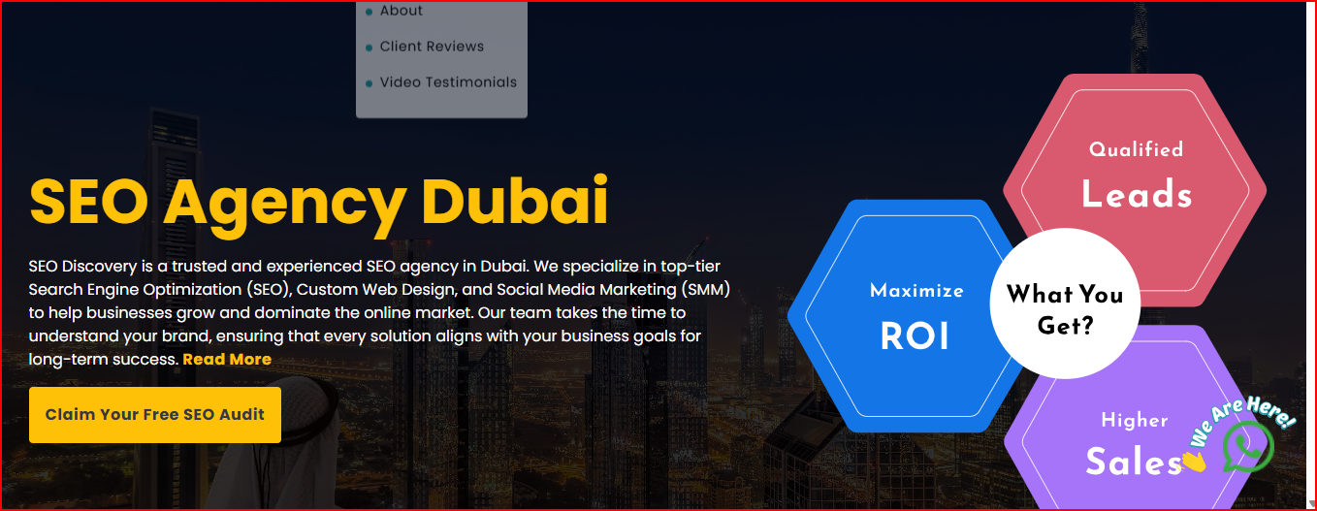

**Local SEO Services in Noida**

Our local SEO services in Noida are designed to help your business reach customers right where they are searching. By targeting geo-specific keywords, optimizing your Google Business Profile, and building citations, we ensure your business ranks higher in local search results. We are a **local SEO agency in Noida** that understands the city’s competitive digital landscape and delivers customized strategies to boost your online and offline visibility.

**Our Local SEO Services Work Process**

We follow a structured and result-oriented process to ensure every client gets the maximum return on their SEO investment:

**1. Local SEO Audit**

We start with a comprehensive SEO audit that identifies your current local SEO performance. Our experts analyze your Google Business Profile, NAP consistency, website structure, backlinks, and local listings. This helps us uncover what’s working and what needs improvement to build a robust local SEO roadmap.

**2. Keyword & Competitor Research**

We dive deep into **geo-targeted keyword research** that aligns with your services and customer intent. Our team also studies your top competitors in Noida to understand their strategies and identify keyword opportunities. We focus on terms like “best services near me” and “local providers in Noida” to drive location-based traffic.

**3. Google Business Profile Optimization**

We fully optimize your Google Business Profile with the correct business name, address, phone number, business categories, descriptions, images, and regular updates. This ensures that your business appears in the top results for local map packs and attracts more calls, visits, and leads.

**4. Local Citations & Listings**

We submit your business information to trusted local directories and industry-specific portals. Consistent NAP data across platforms like JustDial, Sulekha, and Yelp boosts your local rankings. We also manage and monitor these listings to ensure accuracy over time.

**5. Localized Content Marketing**

Content is key in local SEO. We create blogs, landing pages, and service pages that focus on **local keywords** and community topics. This helps attract local backlinks, build trust with your audience, and establish your business as a local authority in Noida.

**6. Review & Reputation Management**

Online reviews influence local rankings. We implement strategies to increase genuine customer reviews on platforms like Google and Facebook. We also help manage and respond to reviews professionally to enhance your online reputation and build trust with new customers.

**Our Client Work**

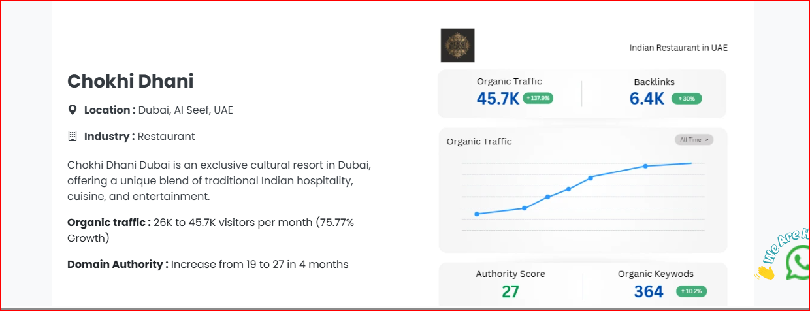

[**https://www.seodiscovery.com/seo-agency-dubai.php**](https://www.seodiscovery.com/seo-agency-dubai.php)

**Yaha pe jaise humne wordpress website pe client work show kia h same to same section add hoga but yaha pe SEO k liye -ok**

**How Lead Generation is Facilitated by Local SEO Services**

**Local SEO directly impacts lead generation** by increasing your visibility in local searches. Here’s how:

* **Higher Visibility on Google Maps & Search** – More clicks and calls.
* **Targeted Local Traffic** – Reach people ready to buy in your area.
* **Trust Through Reviews** – Builds credibility, converting visitors into leads.
* **Mobile-Friendly Listings** – 60% of local searches come from mobile users.
* **Google Business Optimization** – One-click directions, calls, and bookings.
* **Consistent NAP & Local Backlinks** – Helps Google trust your business location.



Refreance Link - <https://ishraq.agency/?gad_source=1&gad_campaignid=21525677490&gbraid=0AAAAA9-X8gLNbEGNjQoEeattS2u7_N0xz&gclid=CjwKCAjw1dLDBhBoEiwAQNRiQSoeX85vZKc7ZuM0_FkzmxB6VSqeVuNhFd0FjR4yVQHI1B5l92FxXxoCYfoQAvD_BwE>

**Why We are the Best Local SEO Agency in Noida?**

Here’s why **RS Organisation** is considered the **Top SEO Company in Noida**:

1. **Proven Local SEO Expertise**  
   With over 7 years of experience, our team includes **local SEO experts in Noida** who understand regional search patterns, customer behaviour, and algorithm updates that affect local businesses.
2. **Custom Strategy for Every Business**  
   We don’t believe in one-size-fits-all. Each campaign is crafted to match the unique goals of your business — whether it’s more phone calls, store visits, or service bookings.
3. **Affordable SEO Packages**  
   Our pricing is transparent and flexible. Small businesses and startups can take advantage of our **affordable local SEO packages** that deliver ROI without burning a hole in your marketing budget.

**Dedicated Account Managers**  
You get a single point of contact to track your progress, ask questions, and receive monthly performance reports — ensuring complete clarity.

1. **Local Citation & Directory Expertise**  
   We manually list and maintain your business in high-DA local directories, improving your credibility and boosting local rankings.
2. **Focus on Conversions, Not Just Rankings**  
   While rankings are great, we focus on actual leads and conversions. Our strategies are designed to increase footfall, phone inquiries, and website leads from Noida customers.
3. **Mobile Optimization & Voice Search Ready**  
   With the rise of “near me” searches, we ensure your content is mobile-friendly and voice-search optimized to capture more real-time customers.
4. **Reputation Building & Review Strategy**  
   We help you earn positive reviews and manage customer feedback professionally, which builds strong trust and helps with SEO performance.
5. **Transparent Reporting**  
   We share easy-to-understand, data-rich reports that showcase your growth in local rankings, web traffic, click-to-call actions, and more.
6. **Trusted by Local Businesses**  
   Dozens of Noida-based service providers, retailers, clinics, and cafes have grown their visibility and customer base through our **local SEO services**.

**Our Technology Stack for Local SEO Success**

1. Google Search Console & Google Analytics
2. Google Business Profile Manager
3. SEMrush / Ahrefs
4. Moz Local & BrightLocal
5. Screaming Frog SEO Spider
6. Surfer SEO / Frase.io
7. Schema Markup Generator
8. GTmetrix / PageSpeed Insights
9. Review Management Tools (e.g., Grade.us)
10. . Rank Tracking Tools

Industries We Serve

Google review

Other reference Idea links

<https://seosherpa.com/locations/dubai/>

<https://www.seodiscovery.com/seo-agency-dubai.php>